System Architecture

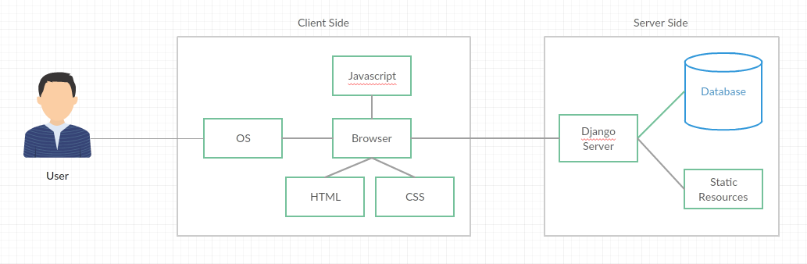

The user accesses the app through a browser on their computer. The server has access to a database and some static resources, such as images. The database will hold the data for the number of houses and rooms, and the contents of each room, as well as the party's cache and survivor stats.
Most game logic will done using python, running on the server, but some logic will be done client-side using javascript. For example game logic such as fighting or running from zombies will be done server-side, but determining what happens (where the browser navigates) when the user clicks will have to be done client-side.
Visuals will be done using html and CSS, using image resources. Little will be stored as text and rendered at the time. This way we can ensure exact reproduction on all platforms. The only downsides to this method are that images take considerably more space than text to store, and that images are harder to edit later on. However, the app will be very small, so image size isn't an issue in this case, and there won't be many images, so edit-times will not make as big a difference as in larger apps, making the benefits outweigh the costs.
The app will run at a low resolution, allowing it to be viewed fully on an 800x600 screen. On larger screens white borders will be placed either side. This also allowed the app to be embedded easily in other pages, through use of inline frames or similar.

